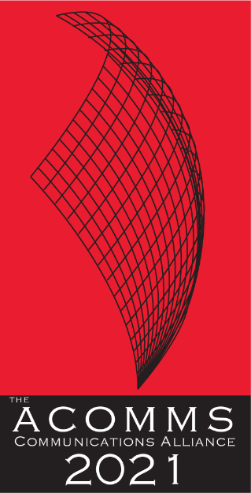 | NOMINATION FORM  AWARD CATEGORY  AUSTRALIAN SPACE INDUSTRY AWARD  Recognises excellence in the provision of satellite communications or satellite/space-related products and services in the Australian space industry

IMPORTANT DATES
Launch of the Awards/Nominations open | Monday, 22nd February 2021
Nominations Close | Friday, 21st May 2021
Announcement of Shortlist | Wednesday, 7th July 2021
Awards Dinner and Awards Presentations | Wednesday, 18th August 2021

NOMINATION CHECKLIST:
- This Award is open to Satellite providers & manufacturers of satellite/space-related products, satellite service operators and infrastructure providers, launch providers, consultants and researchers.
- Satellite initiatives and/or projects undertaken by the company or an individual in Australia.
- Nominee must own the IP of the solution which they are nominating for the award
- This Satellite initiatives and/or projects has NOT won an ACOMMS Award in the previous three years. It is ineligible to enter the award that has won in the previous three years, with or without enhancement.
- Each section of the Nomination form has been completed
The judges can only assess the nomination on the information and materials supplied on the nomination form, so we advise nominees to provide as much information as possible including the suggested Inclusions and supporting testimonials.

AUTHORISATION
By submitting my nomination electronically, I hereby declare that the information provided for the 2021 ACOMM Awards entry is accurate and correct. I also agree to abide by the judging decisions made by the judging panel and their decisions will be accepted and final.
Name
Company

CONTACT INFORMATION:
ORGANISATION NAME/COMPANY
NUMBER OF STAFF IN AUSTRALIA
CONTACT NAME
JOB TITLE
ADDRESS
PHONE
MOBILE
EMAIL ADDRESS

Name of product or service nominated for this award
Date product or service introduced to the market place.

CRITERIA: (Maximum 500 words each)
1. | Describe the initiatives and/or projects
2. | How has it added value to the satellite sector and/or Australian community.
3. | If applicable, how it exceeds any existing industry standards or benchmarks.

SUGGESTED INCLUSIONS:
- What tangible and quantifiable results help to demonstrate the success of the initiatives put in place now and in the future?
- How has the initiatives and/or projects helped Australian consumers or businesses improve their lives or commercial endeavours?

DO NOT FORGET TO INCLUDE SUPPORTING TESTIMONIALS.

NOMINATION OVERVIEW:
Concise company profile overview.
(max. 250 words)
Short description of the entry.
(max. 50 words)
Please attach your Company Logo: A high res (1MG in eps or aif) version of your company logo. The ACOMMS will only use your logo if your entry is shortlisted as a finalist in its given category.
If you agreed for your nomination to be eligible to feature in The Australian (see cover page)
Quote for The Australian
from an appropriate company representative)
Please attach a photo: to run alongside the news story

