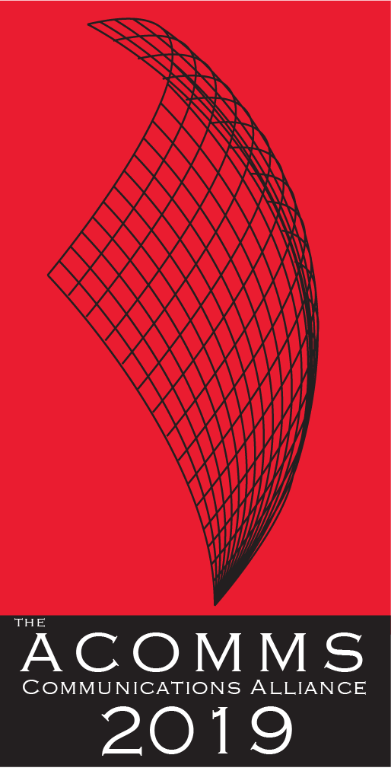 | NOMINATION FORM  AWARD CATEGORY  BEST MARKETING INITIATIVE  Recognises a company that has executed an innovative and successful marketing campaign.

IMPORTANT DATES
Launch of the Awards/Nominations open | Monday 18th February 2019
Nominations Close | Friday 10th May 2019
Announcement of Shortlist | Thursday, 4th July 2019
Awards Dinner and Awards Presentations | Thursday, 15th August 2019

ELIGIBILITY CHECKLIST:
- Industry marketing initiative and/or campaign undertaken by the company or an individual in Australia within 2018/19 or earlier.
- The nominees company is registered and operating in Australia (ABN on request)
- Nominee must own the IP of the solution which they are nominating for the award
- This marketing initiative and/or campaign has NOT won an ACOMMS Award in the previous three years. It is ineligible to enter the award that has won in the previous three years, with or without enhancement.
- Each section of the Nomination form has been completed
The judges can only assess the nomination on the information and materials supplied on the nomination form, so we advise nominees to provide as much information as possible including the suggested Inclusions and supporting testimonials.

MEDIA PARTNER
The ACOMMS is proud to be partnering with The Australian newspaper - the country’s leading national news brand.
Your nomination may be selected to feature in The Australian in a news story featuring your company in the weeks leading up to the ACOMM awards presentation and/or in a Special Report to be published in The Australian after the Awards night.
If you agree to be eligible for selection, you are required to include a suitable photograph to run alongside the news story and a quote from an appropriate company representative.
If you do not want your nomination to be included for selection, please opt out by ticking this box.

AUTHORISATION
By submitting my nomination electronically, I hereby declare that the information provided for the 2019 ACOMM Awards entry is accurate and correct. I also agree to abide by the judging decisions made by the judging panel and their decisions will be accepted and final.
name
company

CONTACT INFORMATION:
ORGANISATION NAME/COMPANY
NUMBER OF STAFF IN AUSTRALIA
CONTACT NAME
JOB TITLE
ADDRESS
PHONE
MOBILE
EMAIL ADDRESS

Name of marketing initiative/campaign nominated for this award
Date of the industry marketing initiative/campaign.

CRITERIA: (Maximum 500 words each)
1. | Describe the marketing Initiative/campaign.
2. | Outline the key strengths and outcomes from a product, consumer and/or corporate perspective.
3. | Provide examples and evidence of the outcome.

SUGGESTED INCLUSIONS:
- Links to marketing initiative and/or campaign on a website
- Marketing material (Softcopy attachment)

DO NOT FORGET TO INCLUDE SUPPORTING TESTIMONIALS.

NOMINATION OVERVIEW:
Concise company profile overview.
(max. 250 words)
Short description of the entry.
(max. 50 words)
Please attach your Company Logo: A high res (1MG in eps or aif) version of your company logo. The ACOMMS will only use your logo if your entry is shortlisted as a finalist in its given category.
If you agreed for your nomination to be eligible to feature in The Australian (see cover page)
Quote for The Australian
from an appropriate company representative)
Please attach a photo: to run alongside the news story

